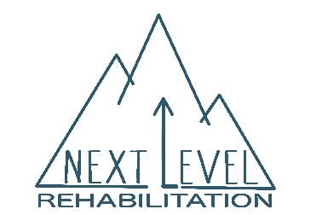
Next Level Rehabilitation
108 Plant Avenue Wayne, PA 19087 P: 610.389.4845 F: 484.580.2141
Medical History Form

Name: _____________________________________________________ Date: ___________
Do you have a history of any of the following?
High Blood Pressure Y N Arthritis Y N Kidney Disease Y N
Angina/Chest Pain Y N Hepatitis/HIV Y N Liver Disease Y N
Heart Disease Y N Seizures Y N Thyroid Problem Y N
Stroke Y N Headaches Y N Urinary Issues Y N
Diabetes Y N Depression Y N Gastrointestinal Y N
Osteoprosis Y N COPD Y N Hearing Difficulties Y N
Cancer Y N Asthma Y N Vision Difficulties Y N
If answered ‘Yes,’ please provide details:____________________________________________________________
_____________________________________________________________________________________________

In the past 3 months, have you experienced any of the following?
Hospitalization Y N Change in bowel or bladder Y N Nausea/Vomiting Y N
Shortness of breath Y N Unexplained weight change Y N Numbness/Tingling Y N
Dizziness Y N Upper respiratory infection Y N Fever/Chills/Sweats Y N
If answered “Yes,” Please provide details:___________________________________________________________
_____________________________________________________________________________________________
Quick Screen
Pregnant or planning to become pregnant? Y N Do you smoke or use tobacco products? Y N
Have you fallen 2 or more times in the past year? Y N If so, any injuries? ______________________

Medications: Please list any medications, supplements, or vitamins that you take regularly.
__________________________________________________________________________________________________________________________________________________________________________________________________________________________________________________________________________________________________________________________________________________________________________________________________________________________________________________________________

Surgeries: (Please list and date)________________________________________________________________
____________________________________________________________________________________________________________________________________________________________________________________
On the image below, please use the indicated symbols to mark the location and nature of your symptoms
SHARP PAIN ACHINESS BURNING PINS & NEEDLES NUMBNESS
///// XXXXX !!!!!! 00000 +++++

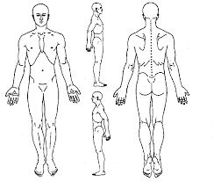
Please record symptoms below for all locations involved:
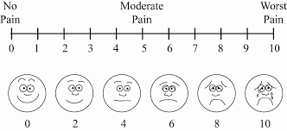
(Example: Neck 4-5/10, Back 6-7/10, Right leg 2-3/10)
___________________________________________________
___________________________________________________
___________________________________________________
___________________________________________________

Patient Signature:___________________________________________________________ Date: __________

