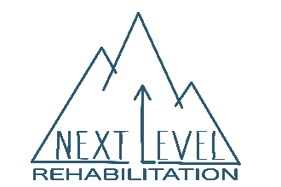
Next Level Rehabilitation
108 Plant Avenue Wayne, PA 19087 P: 610.389.4845 F: 484.580.2141

Patient Intake & Consent Form

Patient Name:_________________________________________ DOB: ______________ Date:____________
Address: __________________________________________________________________________________
Phone: _________________________ Email: _____________________________________________________
Emergency Contact: (Name & relationship)___________________________Phone :______________________
Diagnosis/ Body part(s) involved:_______________________________________________________________
Referring physician:____________________________________ Primary physician:______________________
How did you find out about Next Level Rehabilitation? _____________________________________________

Payment: Next Level Rehabilitation is a fee for service provider. Each session is one hour of one-to-one care with the physical therapist. The initial evaluation is $175. Follow-up appointments are $150. Payments are due at the time of service. Cash, debt, credit and checks are accepted. Formal documentation on treatments and payments can be given so that you can personally submit to your insurance provider for reimbursement.
Cancellation/No-show Policy: Next Level Rehabilitation takes the subject of canceling your appointment very seriously, as it can make the difference as to whether you recover from your injury or condition. However, we also understand the stressors of our daily life. Next Level Rehabilitation requires 24 hours-notice for the cancellation (if not rescheduled within that same week). There is a FULL charge for a no-show or cancellation WITHOUT proper notice.
Informed consent: I hereby consent to evaluation and treatment of my condition by a licensed physical therapist employed by or under contract with Next Level Rehabilitation. I am aware that the physical therapist will inform me of the expected benefits and possible discomfort, which may result from skilled physical therapy care. I am aware that there is not a guarantee that the proposed course of treatment will improve my condition and that it is possible, although unlikely, that the course of treatment may cause additional pain or discomfort or aggravate my condition.
It is your right to decline any part of your treatment at any time before or during treatment, should you feel any discomfort or pain or have other unresolved concerns. It is your right to ask your physical therapist about the treatment they have planned based on your individual history, physical therapy diagnosis, symptoms, and examination results.
I confirm that I have read and fully understand this consent form.
Patient (or parent if under 18) signature: _______________________________________Date :____________

